Name:Kishore Kumar S
Registration number : 192565013

CSA 0421 - OPERATING SYSTEM

Experiment 1:
Create a new process by invoking the appropriate system call. Get the process identifier of the
currently running process and its respective parent using system calls and display the same
using a C program.

Executable C program :
#include <stdio.h> #include <stdlib.h> int main()
{
FILE *fptr1, *fptr2; char filename[100], c;
printf("Enter the filename to open for reading \n"); scanf("%s", filename);
fptr1 = fopen(filename, "r"); if (fptr1 == NULL)
{
printf("Cannot open file %s \n", filename); exit(0);
}
printf("Enter the filename to open for writing \n"); scanf("%s", filename);
fptr2 = fopen(filename, "w"); if(fptr2 == NULL)
{
printf("Cannot open file %s \n", filename); exit(0);
}
c = fgetc(fptr1); while (c != EOF)
{
fputc(c, fptr2); c = fgetc(fptr1);
}
printf("\nContents copied to %s", filename); fclose(fptr1);
fclose(fptr2);
return 0;
}

Output Screenshot:
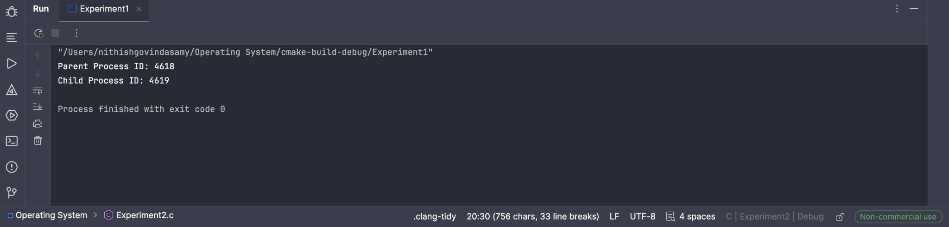

Experiment 2:
Identify the system calls to copy the content of one file to another and illustrate the same using
a C program.

Executable C code :
#include <stdio.h> #include <stdlib.h> int main()
{
FILE *fptr1, *fptr2; char filename[100], c;
printf("Enter the filename to open for reading \n"); scanf("%s", filename);
fptr1 = fopen(filename, "r"); if (fptr1 == NULL)
{
printf("Cannot open file %s \n", filename); exit(0);
}
printf("Enter the filename to open for writing \n"); scanf("%s", filename);
fptr2 = fopen(filename, "w"); if(fptr2 == NULL)
{
printf("Cannot open file %s \n", filename); exit(0);
}
c = fgetc(fptr1); while (c != EOF)
{
fputc(c, fptr2); c = fgetc(fptr1);
}
printf("\nContents copied to %s", filename); fclose(fptr1);
fclose(fptr2); return 0;
}

Output screenshot:
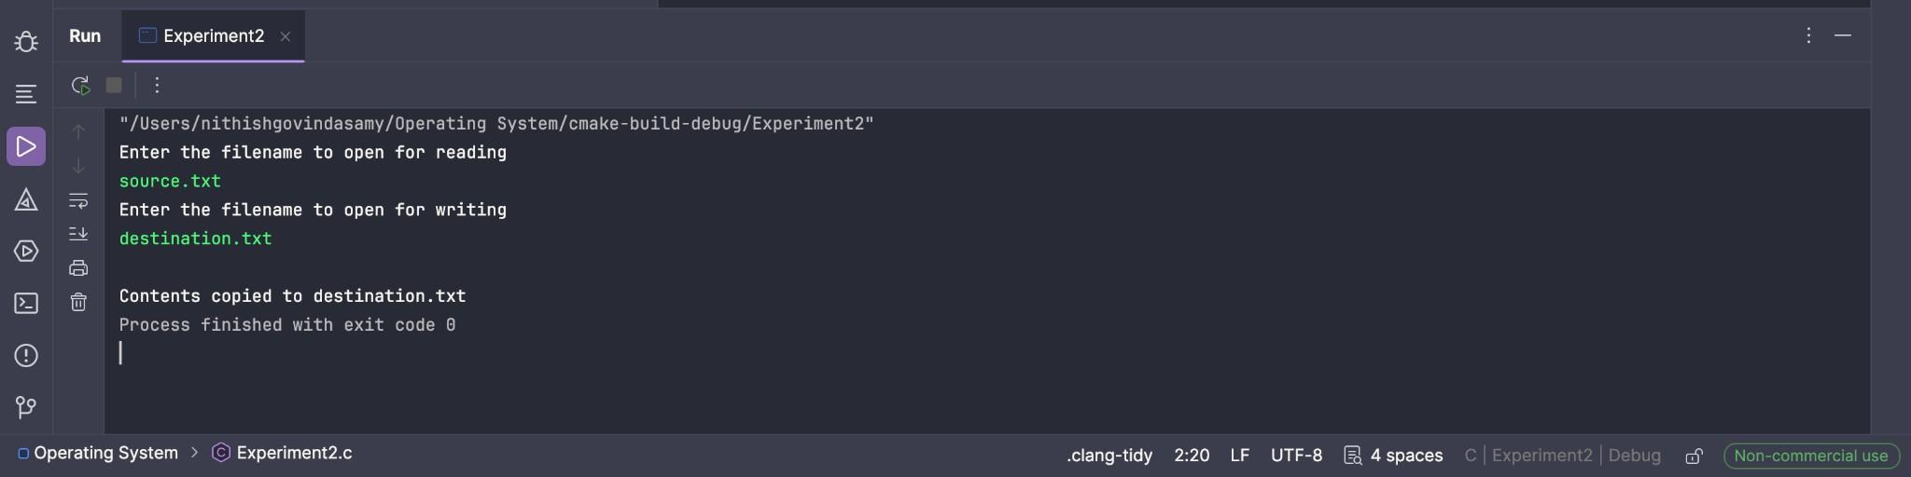

Experiment 3 :
Design a CPU scheduling program with C using First Come First Served technique with the
following considerations.
- All processes are activated at time 0.
- Assume that no process waits on I/O devices.

Executable C code:
#include <stdio.h>

int main() {
int n, i, bt[10], wt[10], tat[10]; float avgwt = 0, avgtat = 0;

printf("Enter number of processes: "); scanf("%d", &n);

printf("Enter burst time of each process:\n"); for (i = 0; i < n; i++) {
printf("P%d: ", i + 1);
scanf("%d", &bt[i]);
}

wt[0] = 0;
for (i = 1; i < n; i++) {
wt[i] = wt[i - 1] + bt[i - 1];
}

printf("\nProcess\tBT\tWT\tTAT\n"); for (i = 0; i < n; i++) {
tat[i] = wt[i] + bt[i]; avgwt += wt[i];
avgtat += tat[i];
printf("P%d\t%d\t%d\t%d\n", i + 1, bt[i], wt[i], tat[i]);
}

printf("\nAverage Waiting Time = %.2f\n", avgwt / n); printf("Average Turnaround Time = %.2f\n", avgtat / n); return 0;
}

Output screenshot:
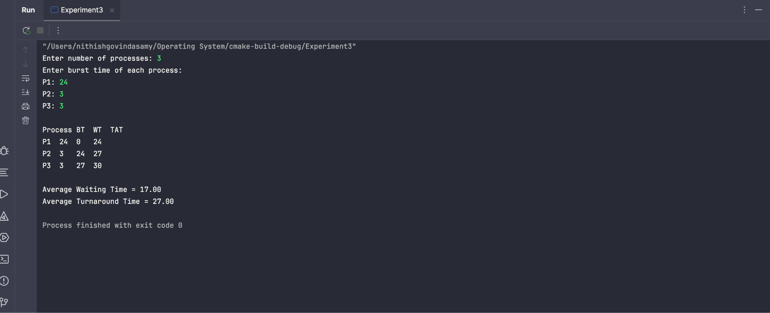

Experiment 4:
Construct a scheduling program with C that selects the waiting process with the smallest
execution time to execute next.

Executable C code:
#include <stdio.h>

int main() {
int n, i, j, temp, p[10], bt[10], wt[10], tat[10]; float avgwt = 0, avgtat = 0;

printf("Enter number of processes: "); scanf("%d", &n);

printf("Enter burst time of each process:\n"); for (i = 0; i < n; i++) {
printf("P%d: ", i + 1);
scanf("%d", &bt[i]); p[i] = i + 1;
}

// sort by burst time
for (i = 0; i < n - 1; i++) { for (j = i + 1; j < n; j++) {
if (bt[i] > bt[j]) {
temp = bt[i]; bt[i] = bt[j]; bt[j] = temp;
temp = p[i]; p[i] = p[j]; p[j] = temp;
}
}
}

wt[0] = 0;
for (i = 1; i < n; i++) {
wt[i] = wt[i - 1] + bt[i - 1];
}

printf("\nProcess\tBT\tWT\tTAT\n"); for (i = 0; i < n; i++) {
tat[i] = wt[i] + bt[i]; avgwt += wt[i];
avgtat += tat[i];
printf("P%d\t%d\t%d\t%d\n", p[i], bt[i], wt[i], tat[i]);
}

printf("\nAverage Waiting Time = %.2f\n", avgwt / n); printf("Average Turnaround Time = %.2f\n", avgtat / n); return 0;
}

Output Screenshot :
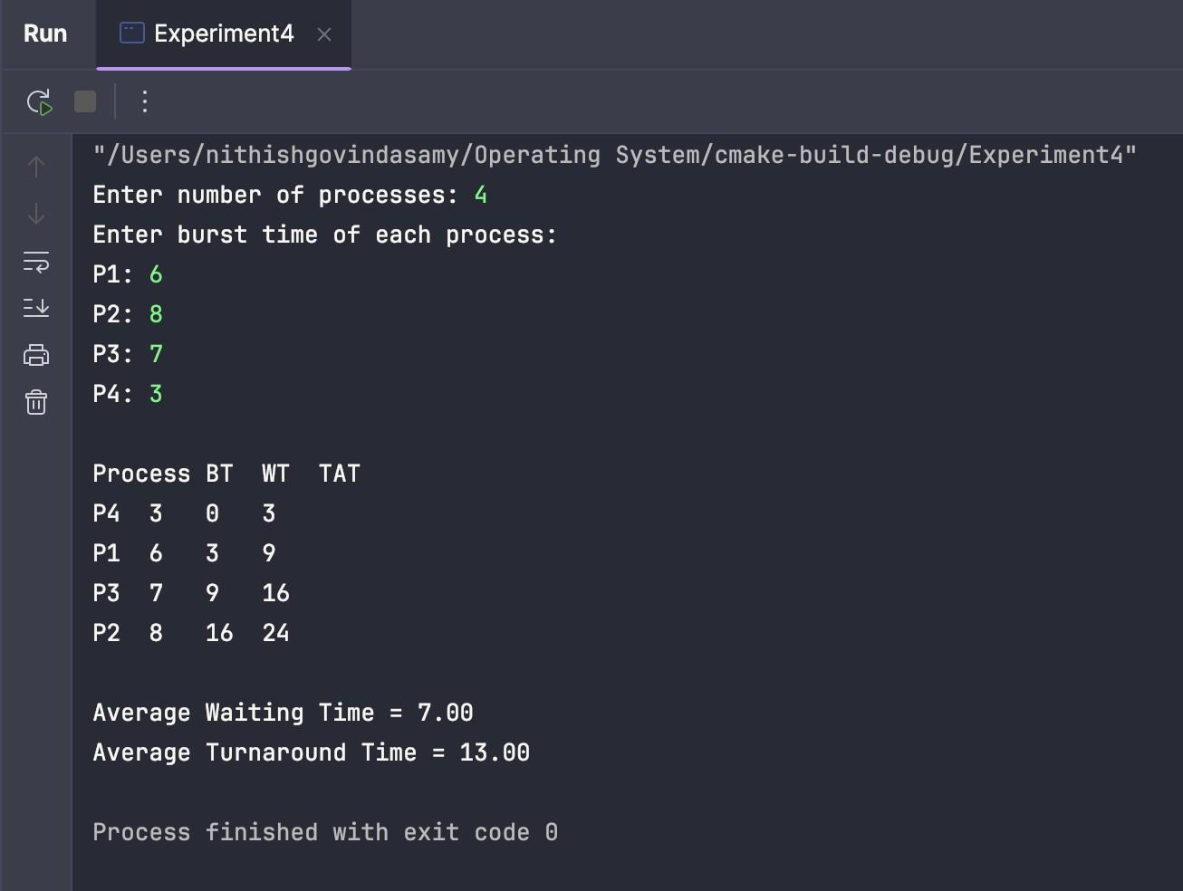

Experiment 5:
Construct a scheduling program with C that selects the waiting process with the highest priority to execute next.
Executable C code :
#include <stdio.h>

int main() {
int n, i, j, temp, p[10], bt[10], pr[10], wt[10], tat[10]; float avgwt = 0, avgtat = 0;

printf("Enter number of processes: "); scanf("%d", &n);

printf("Enter burst time and priority of each process:\n"); for (i = 0; i < n; i++) {
printf("P%d: ", i + 1); scanf("%d %d", &bt[i], &pr[i]); p[i] = i + 1;
}

// sort by priority (lower number = higher priority) for (i = 0; i < n - 1; i++) {
for (j = i + 1; j < n; j++) { if (pr[i] > pr[j]) {
temp = pr[i]; pr[i] = pr[j]; pr[j] = temp;
temp = bt[i]; bt[i] = bt[j]; bt[j] = temp;
temp = p[i]; p[i] = p[j]; p[j] = temp;
}
}
}

wt[0] = 0;
for (i = 1; i < n; i++) {
wt[i] = wt[i - 1] + bt[i - 1];
}

printf("\nProcess\tPriority\tBT\tWT\tTAT\n"); for (i = 0; i < n; i++) {
tat[i] = wt[i] + bt[i]; avgwt += wt[i];
avgtat += tat[i];
printf("P%d\t%d\t\t%d\t%d\t%d\n", p[i], pr[i], bt[i], wt[i], tat[i]);
}

printf("\nAverage Waiting Time = %.2f\n", avgwt / n); printf("Average Turnaround Time = %.2f\n", avgtat / n); return 0;
}

Output screenshot:
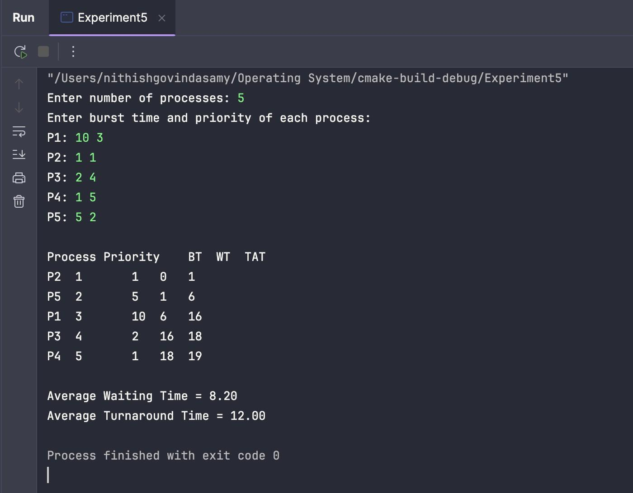
Github repo link : https://github.com/kishore-kumar-2008/CSA-0421-Operating-System

